Analysis: what the new Discounts, Refunds & Rejections model requires
Signature Discounts apply only to Paper, Counter/Walk-In Child Orders — Digital Child Orders are never eligible. Because of this, Signature Discount and General Discount must stay as two distinct fields rather than being merged into a single combined value: merging them would erase which portion was signature-based (paper-only) versus general (paper and digital), and break the separate audit trail the Addendum requires. Recommendation: keep the two fields separate at the Parent Order level as specified, and validate Signature Discount eligibility based on whether the order contains at least one Paper Counter/Walk-In line item.
At checkout and payment, the Parent Order should show the combined discount and total due — the per-child breakdown of how a discount was split should not be surfaced to the CA or the customer. The screen below reflects that:

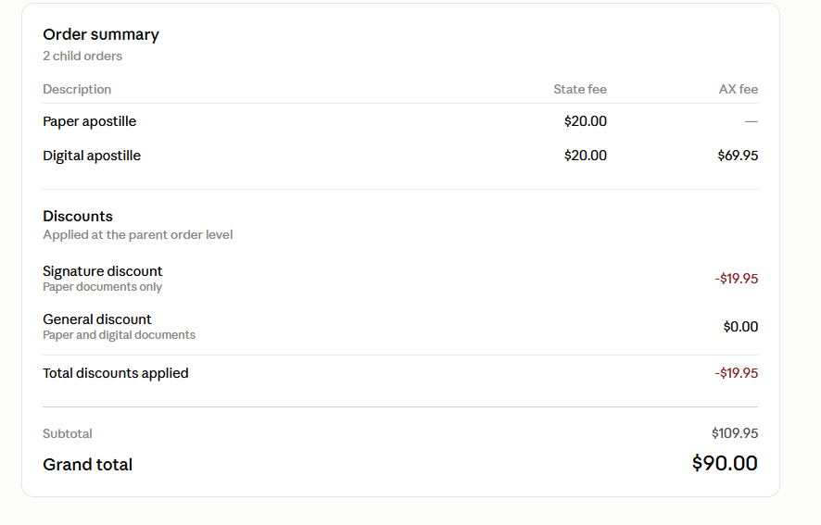
The same principle carries through to the refund experience — the CA should work from the Parent Order's totals, not a per-child dollar figure:
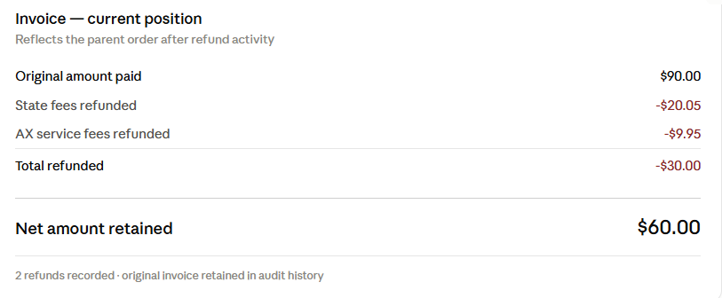

Current state: the Cancel and Refund modals as built today
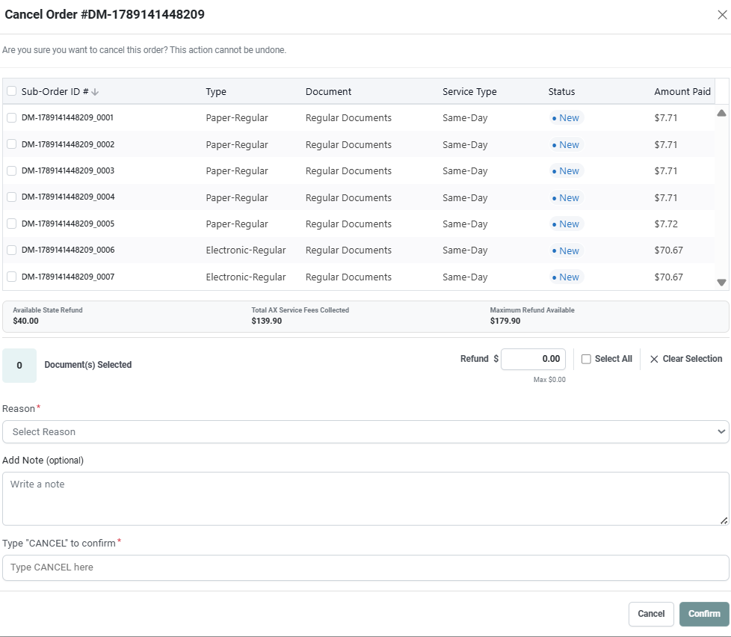
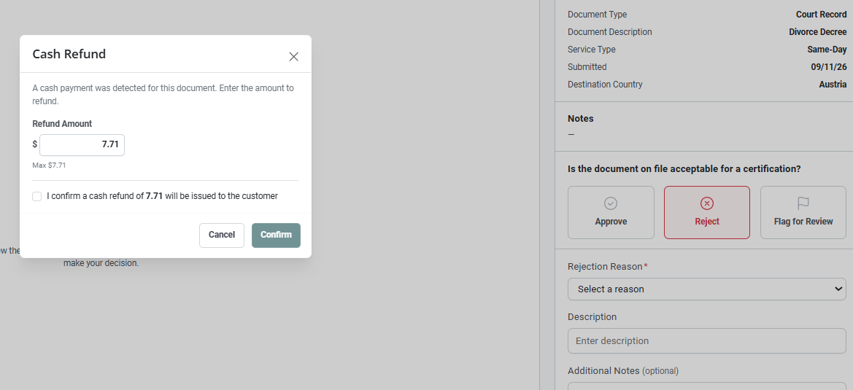
Recommended approach: in the redesigned Cancel / Refund / Reject UI, the CA should only need to confirm a single refund amount at the Parent Order level — no per-Child-Order dollar entry, and no requirement to identify which Child Order the refund belongs to.
Open question: once the checkbox table is no longer tied to the refund amount, how should bulk Cancel / Reject / Revoke actions work? Today, bulk actions run through the same modal checkboxes that currently also drive the refund calculation — removing that dependency raises the question of how bulk status changes should be handled going forward.
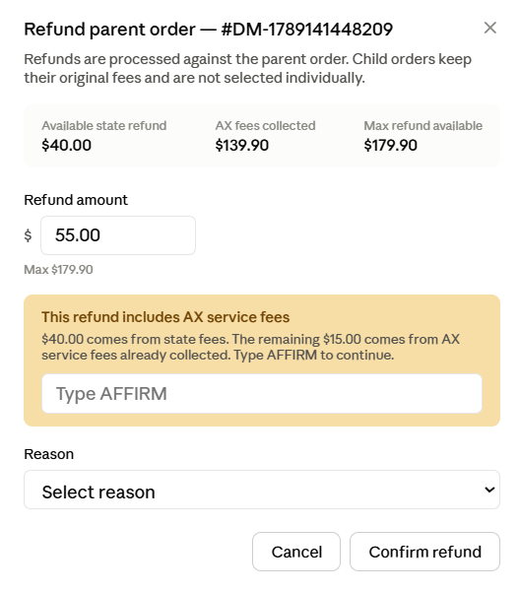

Recommendation: keep the checkbox table for bulk status changes only (selecting which Child Orders move to Cancelled / Rejected / Revoked), and decouple it entirely from the refund amount field, as shown below:
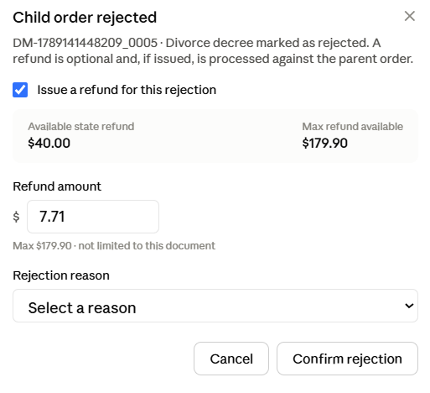
Recommendation: remove the Amount Paid column from this table entirely. Checking a row should only change that Child Order's status; the refund amount should be entered once, independently, and capped by the Parent Order's Maximum Refund Available rather than by the sum of selected rows.

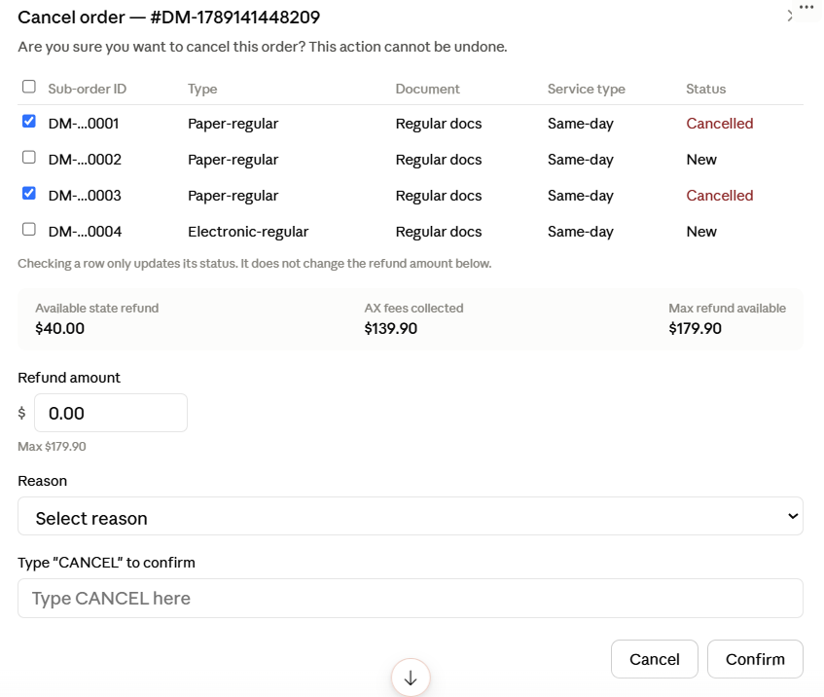

Issue to resolve: as currently designed, a refund tied to a single Child Order can be entered up to the Parent Order's full Maximum Refund Available (e.g., $179.95), even though that Child Order's original charge was only $5.00. Recommendation: when a refund is being issued in connection with a specific Child Order (for example, a Rejection), cap the suggested amount at that Child Order's own original fee by default, while still allowing the CA to enter a different amount up to the Parent Order's Maximum Refund Available where business rules call for it. This prevents an oversized refund being attributed to a single line item.

Current state: today's receipt/invoice layout
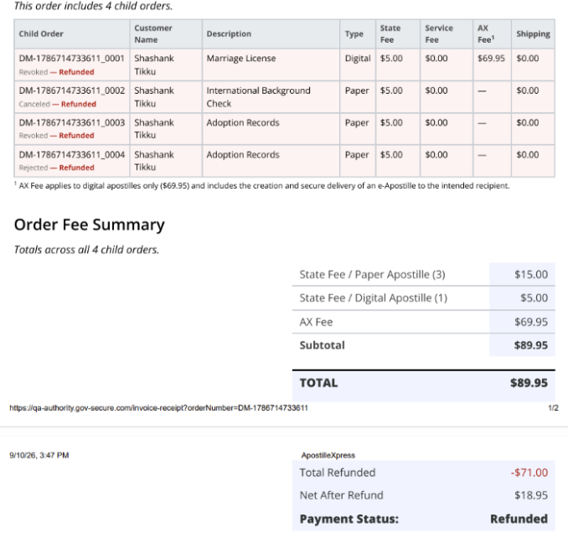

Recommendation: add the following breakdown once one or more refunds have been processed, to satisfy the Addendum's requirement that the Invoice reflect the Parent Order's current financial position:
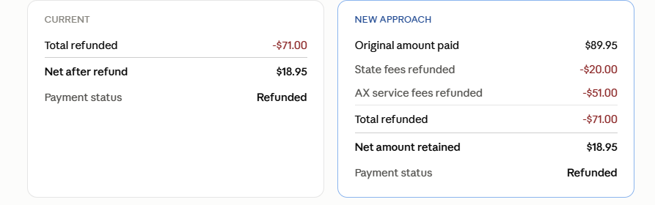
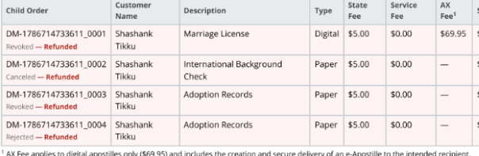Recommendation: introduce a “Partially Refunded” payment status, shown until the full Maximum Refund Available has been used; once fully exhausted, the status should update to “Refunded.”

Answers and recommendations for the project team's open questions:
What exactly should count as the “State Processing Fee” for discount caps and refund
pools?
Today, the amount available for discounts and refunds includes the base state fee, plus any
expedited-processing fee, plus shipping — the system treats all three as one combined “state” bucket.
The Addendum's own worked example only shows a plain $20 state fee, with no mention of the other
two. Should the cap and refund pool include the expedited-service fee and shipping, or should it be
limited to the base state fee alone? This changes the dollar limits in every discount and refund
calculation.
Recommendation: the State Processing Fee used for discount caps and refund pools should include the base state fee, expedited-processing fee, and shipping — all three treated as one combined state-fee pool, consistent with current system behavior. This should still be confirmed explicitly with stakeholders before implementation, since the Addendum's own worked example doesn't show this combination.

How should promotional discount codes fit into this model?
Separately from anything CA staff enter, customers can already apply a promotional discount code at
checkout. That discount currently is allowed to reduce the AX Service Fee, which is the opposite of the
rule this Addendum sets for Signature and General Discounts. The Addendum doesn't mention promo
codes at all. Should promo codes count toward “Total Discounts Applied,” and should they keep their
current exemption from the no-AX-fee-reduction rule, or should that exemption be removed?
This answer addresses No-Bill (NOBILL) handling rather than promotional codes directly — NOBILL will remain in place with no changes, pending stakeholder confirmation. Recommend also providing a direct answer on whether promo codes should count toward Total Discounts Applied and whether they should keep their current exemption from the no-AX-fee-reduction rule, since that is what this question specifically asks.

Should General Discount remain available on Mail-In orders?
Today, CA staff can apply a General Discount to both Walk-In and Mail-In orders. The Addendum
specifies Counter/Walk-In orders only. Please confirm whether Mail-In eligibility should be removed, or
whether the Addendum's wording was meant to describe Signature Discount specifically and General
Discount should stay available more broadly.
Recommendation: General Discount should remain available on Mail-In orders, unchanged from current behavior. Only Signature Discount is restricted to Counter/Walk-In orders under the Addendum — General Discount eligibility should not be narrowed.

Which refund split is authoritative for accounting: the new “state fees first” rule, or the
existing proportional split already used for bookkeeping?
The Addendum calls for refunds to draw down state fees first and only touch AX Service Fees once
state fees are exhausted. Our existing finance and payout reconciliation process already splits every
refund proportionally across state and AX fees, and does not use a “state first” approach. If the
Addendum's rule goes forward for the numbers CA staff and auditors see, finance's own records will
disagree with those numbers unless we're told which one should govern, or the two are reconciled as
part of this project.
Recommendation: the Addendum's “state fees first, then AX fees” rule should be the authoritative refund split for both CA-facing numbers and downstream accounting, replacing the current proportional split used in finance reconciliation. Action item: verify in QA that the AFFIRM prompt appears only once State Fees are fully exhausted and the refund begins drawing from AX Fees; if the current build triggers AFFIRM at a different point, that needs to be corrected before this can be confirmed as working as intended.

How far back should existing orders be rebuilt under the new model?
Three different pricing approaches have been used over time, and orders from all three still exist in the
system. We need a clear decision on which historical orders get fully migrated to the new model, which
get a best-effort reconstruction (clearly labelled as such), and which are simply left on the current
system unchanged going forward.
Open item — needs stakeholder confirmation. Proposed starting point: define a retention/migration cutoff (for example, orders within the last 60 days) that get fully migrated to the new model, with older orders receiving a clearly labelled best-effort reconstruction or being left unchanged. This cutoff is a suggestion, not a decision, and should be confirmed with stakeholders before implementation.

6. Can a rejected request ever go without a refund?
Today, rejecting some paid requests automatically triggers a full refund with no CA discretion, and if the payment
system has an issue, the rejection itself can be blocked from being recorded at all. Under the new model, should CA
staff always be free to reject a request without necessarily refunding anything, and should a rejection ever be blocked
by a refund/payment failure?
Per the Addendum: a Rejection should not automatically trigger a refund. The CA should be prompted to decide whether a refund applies and, if so, the amount, within the normal Parent-level refund limits. Recommend confirming with stakeholders whether a rejection should ever be blocked by a refund or payment failure, since the Addendum doesn't address that specific case.

Should the refund acknowledgment (AFFIRM) be based on the whole order's remaining state-fee
balance, or only the specific items an employee is looking at? -yes
Please confirm the acknowledgment should trigger off the order's total remaining state-fee balance, not a narrower
view scoped to whichever line items happen to be selected on screen.

8. Should refunds require a recorded reason, the same way rejections do?
Rejections already require staff to select a reason and add notes. Should refunds follow the same pattern?
Recommendation: yes, refunds should require a recorded reason, the same way Rejections already do.

9. How should state-billed (“No-Bill”) orders factor into collected and retained totals?
Some orders are billed directly to the state rather than paid by card. A “refund” there is really a credit adjustment, not
money changing hands. How should these be reflected in Total Amount Collected and Net Amount Retained?
No-Bill (state-billed) orders should be updated to reflect the same Parent-level model. Works the same way as regular order, refunds are adjusted and billed at the end of the month

10. Should refund limits be enforced consistently across cash, state-billed, and card payments?
Card refunds are automatically capped by the payment processor. Cash and state-billed refunds currently have no
equivalent built-in cap. Should the same enforced ceiling apply across all payment types?
Recommendation: yes, the same enforced ceiling (Maximum Refund Available) should apply consistently across cash, state-billed, and card payments, not only card refunds where the payment processor already enforces a cap.

11. Should we build a (currently unused) option to bill the CA back for refunded AX Service Fees?
The Addendum describes the no-billback rule as “current business policy,” which suggests it may not be permanent.
Would you like a configurable switch built now, even if it stays off at launch?
Clarifying question for the development team: confirm whether this question is about the No-Bill (state-billed) billing flow specifically, or a separate CA billback mechanism for refunded AX Service Fees. Recommendation: the receipt/invoice should be updated to reflect any billing amount regardless of the answer, but the underlying billback switch itself should be confirmed with stakeholders before being built, even if it stays off at launch.
12. What officially marks the moment a payment counts as “successful” for reporting?
The system doesn't currently store an exact payment-completion timestamp. Is the order submission date an
acceptable stand-in for historical orders, or does the actual payment-processor timing need to be captured going
forward? – order submission date only when customer paid for the order. Date submitted only recorded – saved date only on UTC but they want to be on time preference. We do not record timestamp but we can extract it if needed. When stripe comes back – we can capture it but not Cash – we cannot track back cash…
13. What exactly should count as a “Rejection-Related Refund” in reports?
Should this include every refund on an order that happens to contain any rejected item, or only refunds a CA staff member explicitly ties to a specific rejection? – child is agnostic to refund – we have an order, one child is rejected, we cannot state how much is refund
Recommendation: a Rejection-Related Refund should only be counted when a CA staff member explicitly ties a refund to a specific Rejection — not simply because the order happens to contain a rejected item. When multiple Child Orders are rejected together for the same reason, that reason can be applied to all of them, but each remains its own recorded Rejection event.
14. Should the existing (currently disabled) activity report be replaced or extended? – we need more info on this
An earlier version of activity-level reporting already exists behind a setting that's switched off everywhere except our development environment. Should the new reporting requirements replace it, or build on top of it?
Needs more information from engineering before this can be answered — specifically, what the existing (currently disabled) activity report includes today and where it's configured, so we can determine whether the new reporting requirements should replace it or build on top of it.

15. Is the “common-signature” policy meant to become an actual signature-matching feature, or is
it a label for a fully discretionary discount?
Today, staff simply count signatures — there's no feature that compares or matches “common” signatures against each other. Is that comparison logic expected as new functionality in this project, or should the Signature Discount remain a fully discretionary amount, with counts kept only for audit and future analysis?
Tentative read, needs stakeholder confirmation: this may be understood as a request for an actual signature-matching feature (comparing recorded signatures against one another), rather than the current fully discretionary discount with manually counted signatures. Both the Addendum and the Business Rules Summary describe the Signature Discount as manually applied by the CA with no automatic matching logic — building real matching would be a significant scope addition beyond what's currently documented, so this needs to be confirmed explicitly before it's assumed to be in scope.
16. For purchases that span multiple states, please confirm each state's portion is its own “Parent
Order.” – when order is coming from Universal – the cap for one state is Max and the other state has nothing? If we do not capture per child – we will not know how much money each state can claim
A single customer purchase can include requests for more than one state, and the system already creates a separate order record per state in that case. Please confirm the Addendum's “Parent Order” refers to that per-state record, not the customer's combined purchase across states.

Open item for stakeholder review: confirm whether this new Parent-level Discounts, Refunds & Rejections model is intended to roll out across all states we onboard, or only for Utah at this stage. Maryland should review the scheme and confirm it fits their business rules, since requirements may differ by state. Recommend the CFO also review this model before rollout, specifically flagging two behavior changes that could otherwise land as a surprise: (1) a Rejection no longer automatically triggers a refund — the CA now decides whether to refund and how much; and (2) the refund amount entered may no longer equal the amount actually paid for a specific line item, since refunds are now capped and processed at the Parent Order level rather than tied to a single Child Order's original charge.

Use cases:

Use case 1:
all child orders are mail in - no signature discounts available, $5 per child - 10 orders, $50 total, general discount $10. paid 40. on the refund modal i want refund 3 child orders, amount 10
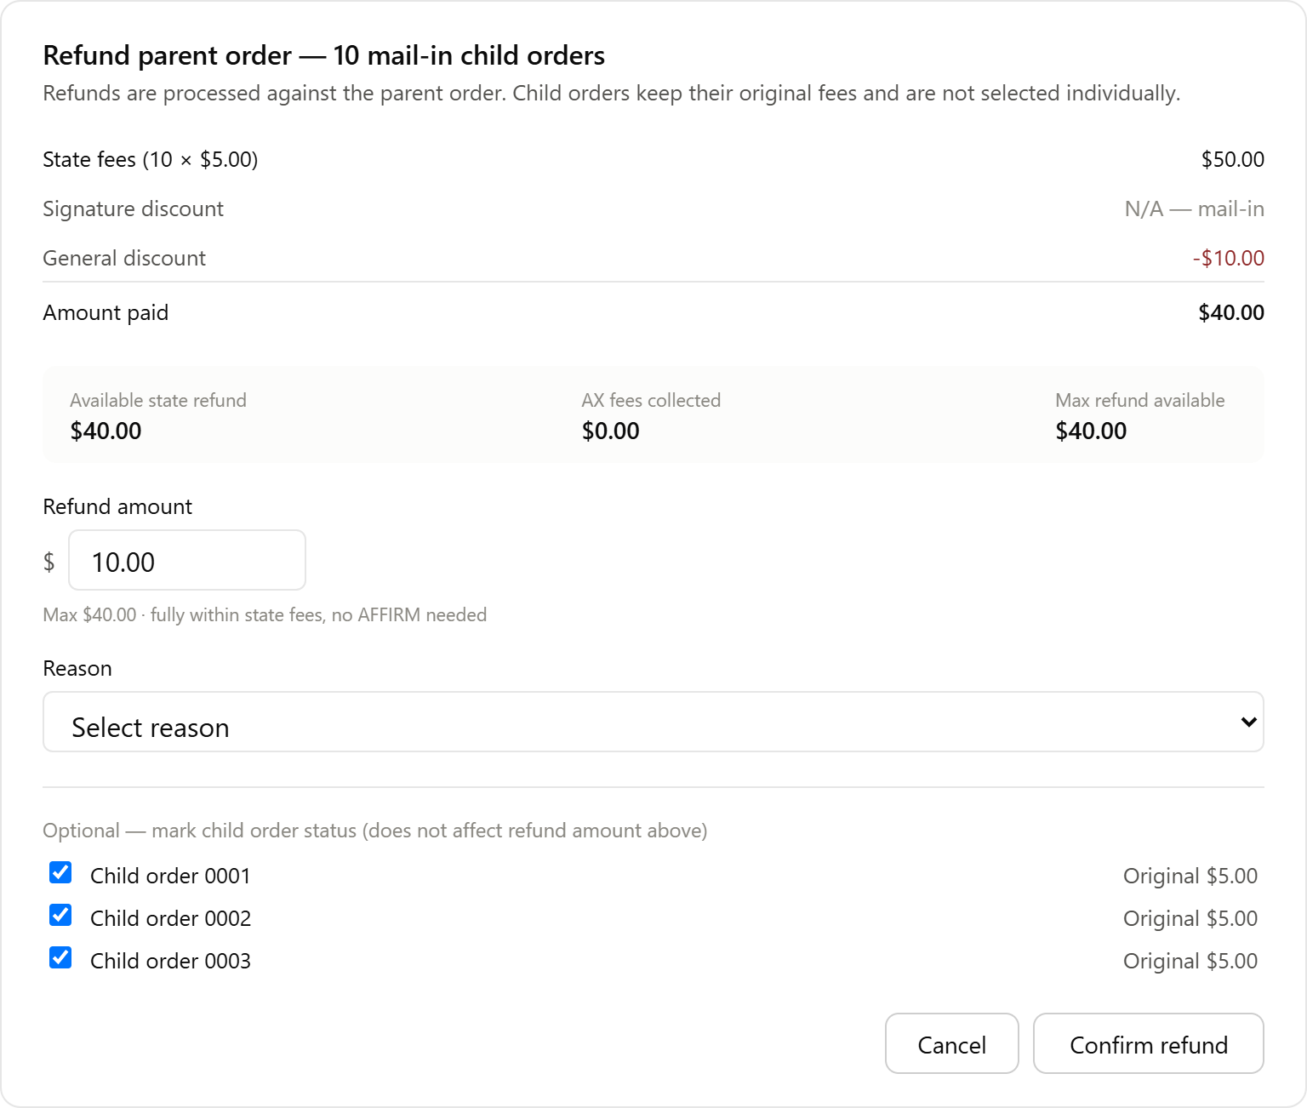

Use case 2:
3 digital Child Orders, each $5.00 State Fee + $69.95 AX Fee. General Discount $10.00 applied (Signature Discount isn't available here either — it's paper-only, regardless of Walk-In/Mail-In)
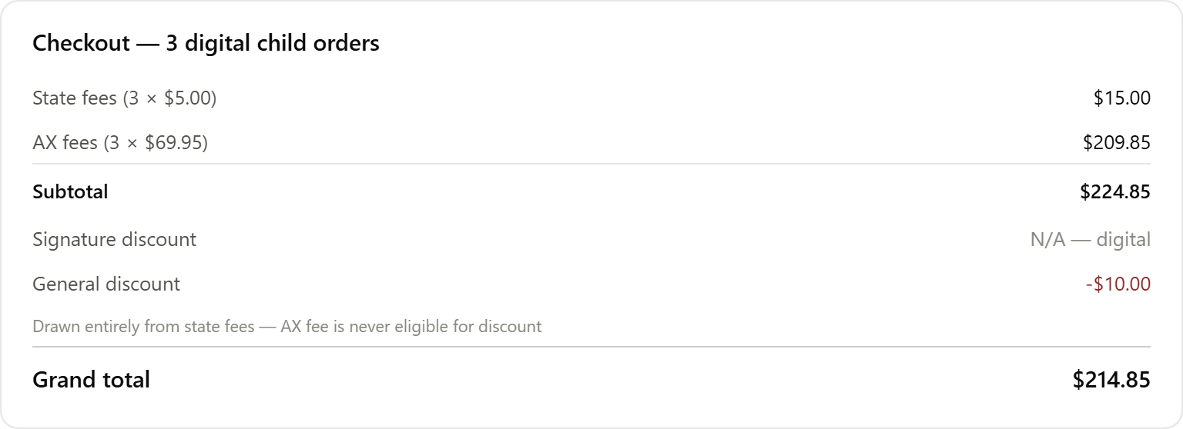

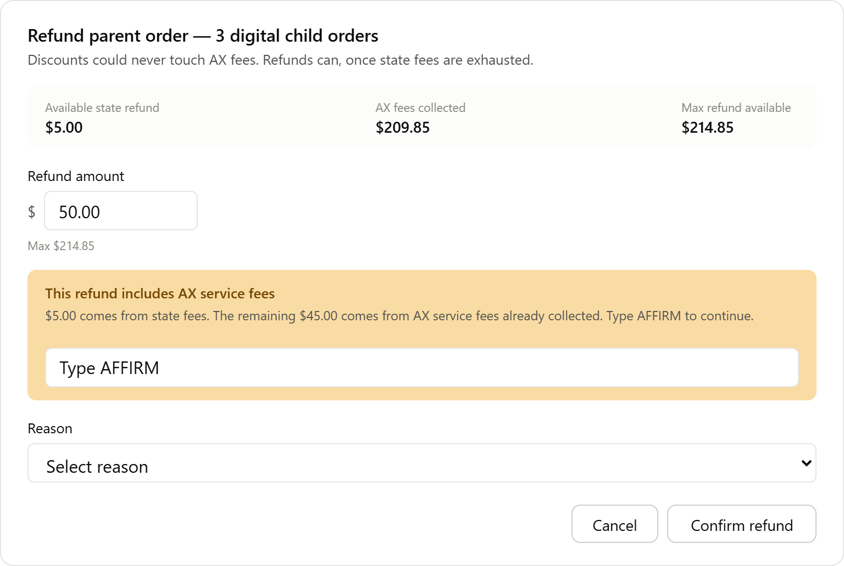
Use case 3:
4 Walk-In Child Orders — 3 paper ($20.00 each) + 1 digital ($5.00 state + $69.95 AX). Signature Discount applies only to the paper ones; General Discount applies across paper and digital.
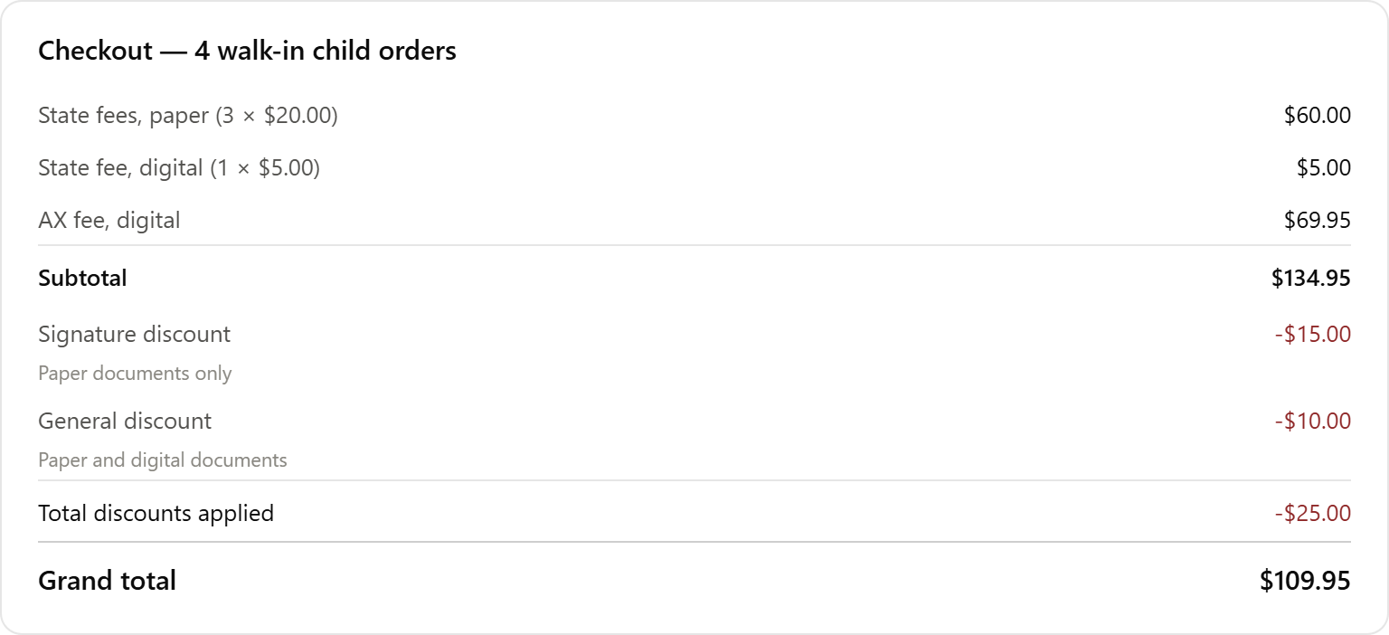
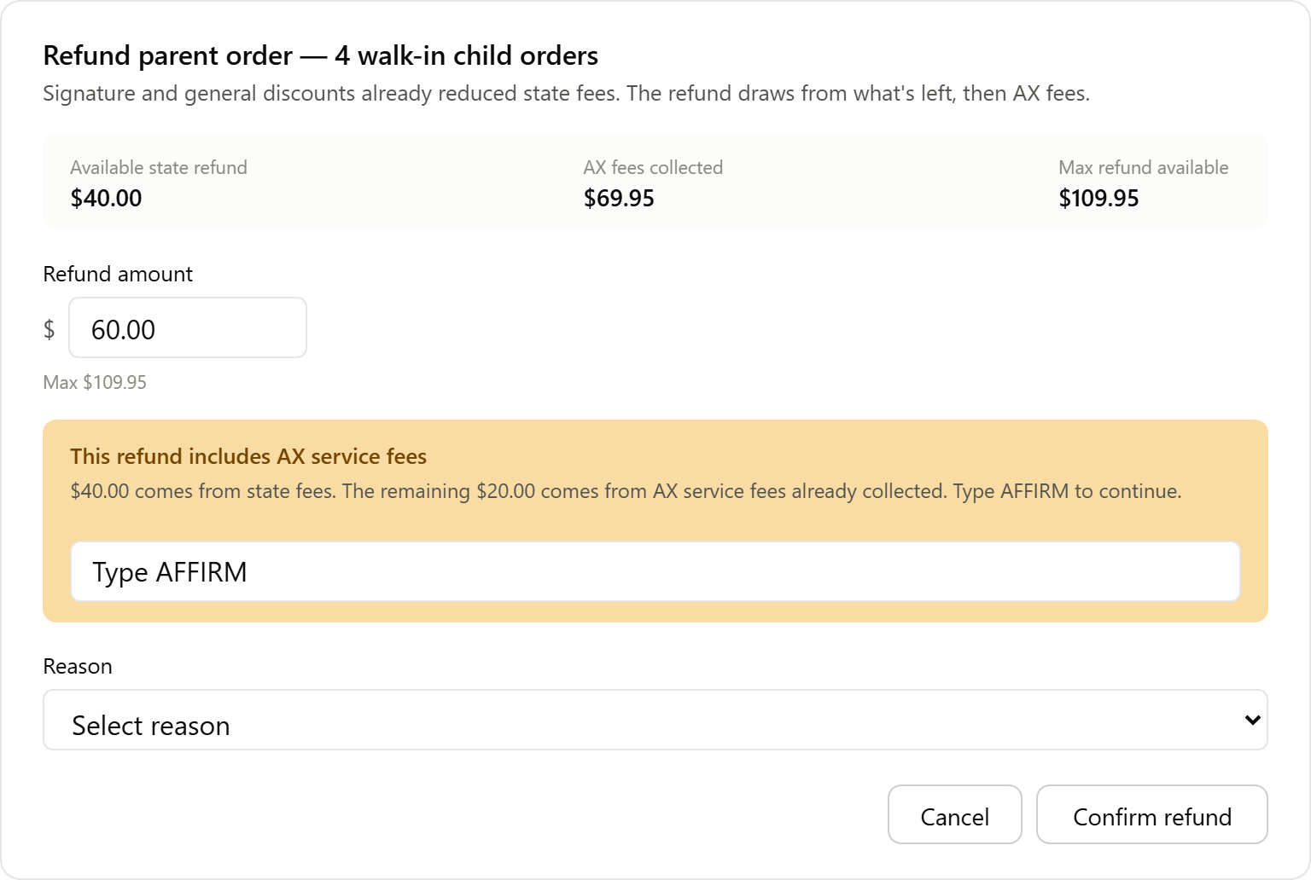

Use case4:
2 paper Walk-In ($20.00 each) + 2 digital Walk-In ($5.00 state + $69.95 AX each). 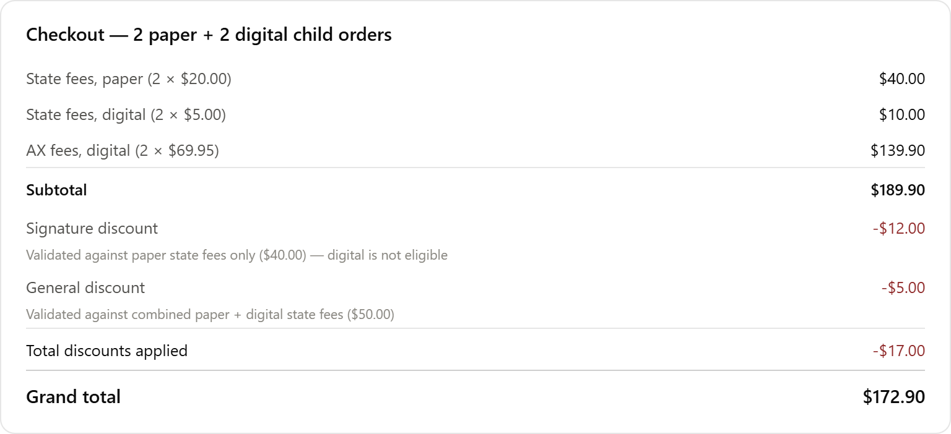

Ch1 5
Ch2 5
Ch3 5

Total 15

*stripe one transaction $15
Refund -5

Below are the main bullet points from the BRD:
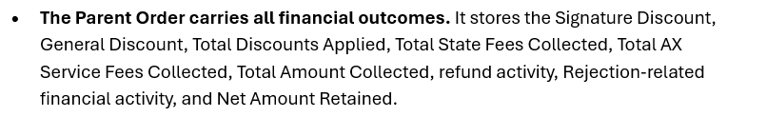
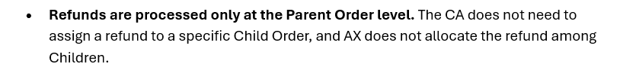
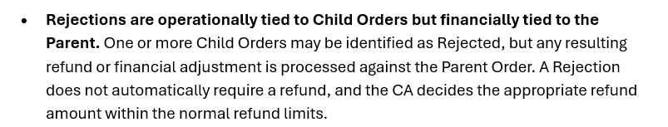
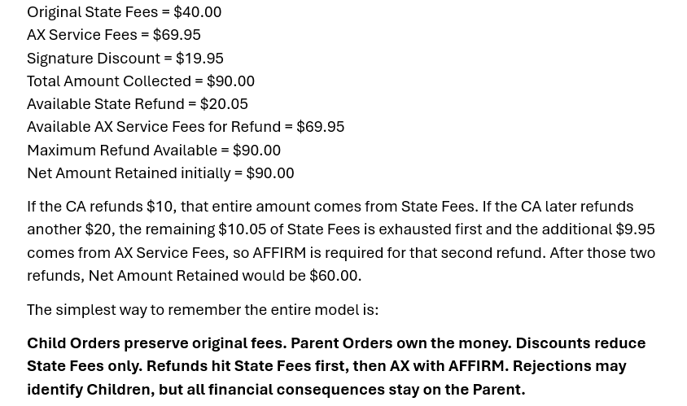
Current Implementation
At present, the discount scheme is functioning as intended:
- Users can create orders and apply:
  - Signature discounts (for walk-in paper orders)
  - General discounts (across all child orders)
- Orders can be paid successfully, with discounted pricing applied at the child order level.
- For refunds, the refunded amount is distributed equally across all child orders. This has already been implemented and is working as designed.
Proposed Change that was received from c-suite:
Based on discussions, the refund model would shift to a parent-order-level approach across platforms.
Under this model:
- The system would only track the total amount paid for the parent order after signature and general discounts.
- We would no longer capture or maintain the amount paid at the child order level.
- Refund eligibility would be determined by the remaining refundable balance on the parent order rather than on individual child orders.
This approach introduces several challenges:
- The system will no longer know how much was actually paid for a specific child order.
- It creates the possibility of over-refunding individual child orders.
- We will lose the ability to accurately determine whether a child order has been fully refunded.
- Child-level refund tracking and reporting may become inconsistent.

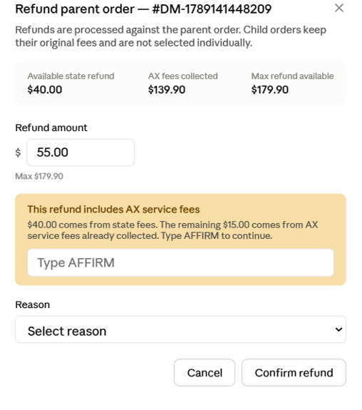
Refunded Status
If we move to this model, should the "Refunded" tag only appear once the entire parent order balance has been refunded and the net amount reaches $0?
In other words, should refunds be tracked exclusively at the parent level rather than the child level?
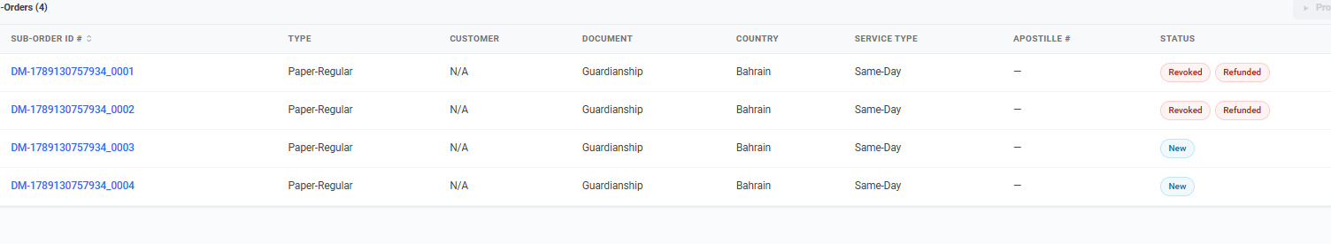
Child Order Selection
The BRD indicates that refunds should be processed at the parent order level and that users should not need to select individual child orders for refund.
However, I strongly recommend retaining the child-order checkboxes, even if refund amounts are no longer tracked individually.
Without the checkboxes:
- Users would need to manually navigate to each child order.
- They would then need to manually update statuses such as:
  - New → Cancelled
  - New → Rejected
  - New → Refunded
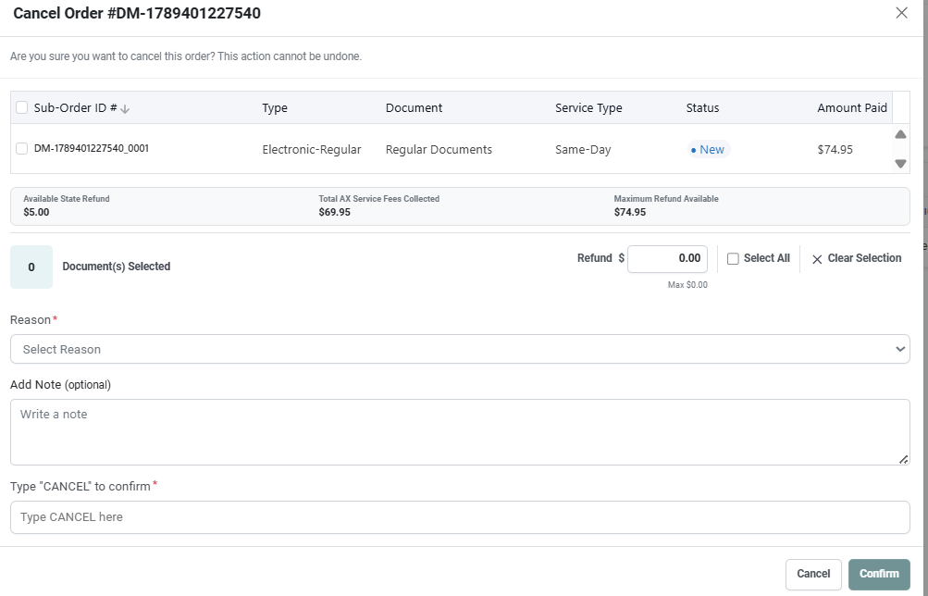
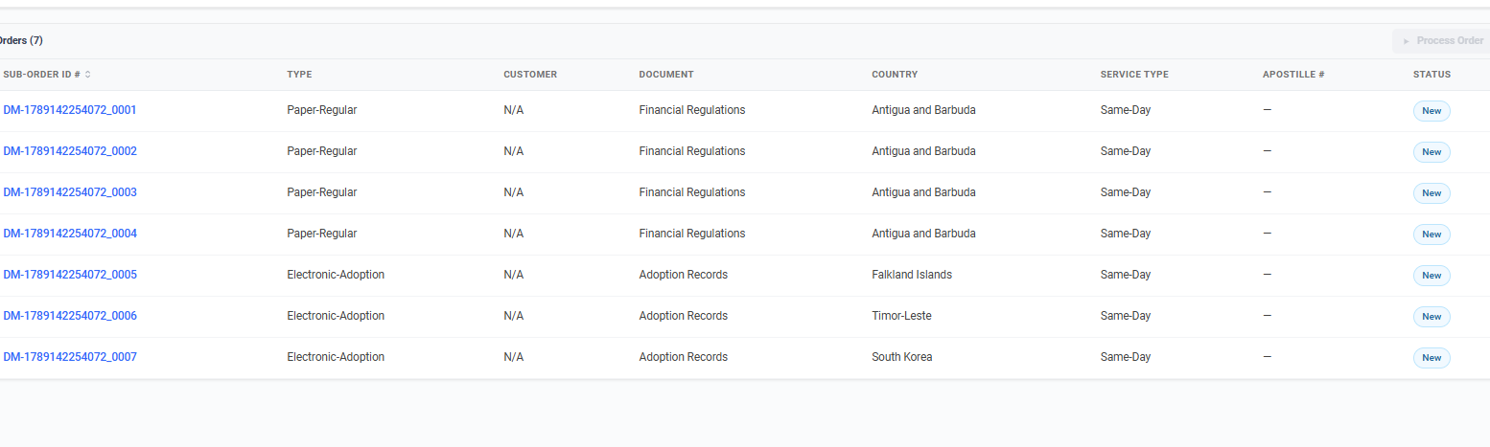
Currently, these actions can be handled more efficiently during the refund process.
Rejected Orders
Another item requiring clarification is the Rejected status.
Today, when an order is rejected, an automatic refund is triggered based on previous requirements.
With the proposed changes:
- Will rejections continue to trigger automatic refunds?
- Or will refunds become an on-demand action?
If refunds are no longer automatic, the rejection workflow and modal should likely be updated to ask users whether they would like to issue a refund as part of the rejection process.
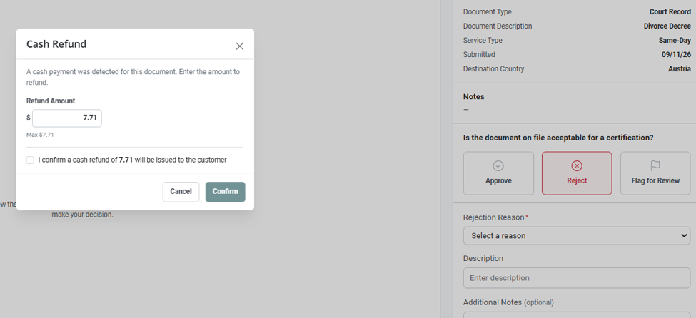
Receipts
Currently, when a child order is refunded, the receipt reflects a Refunded status for that child order.
With the proposed parent-level refund model, should receipts:
- Stop displaying refund status at the child level?

- 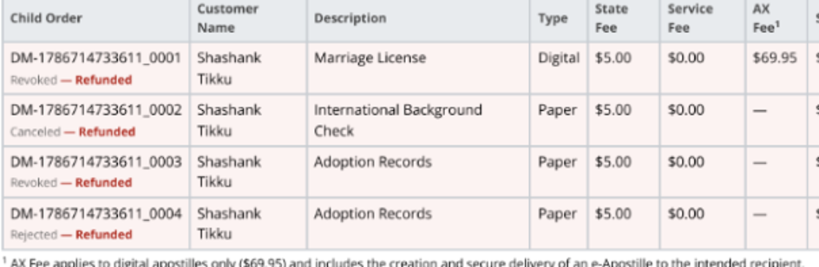

- Instead display refund information only at the parent order level, such as a refund summary at the bottom of the receipt?


(CA) Complimentary Orders
There was no guidance in the BRD regarding NOBILL behavior for CA
Please keep in mind that CA currently supports promo codes that allow users to place complimentary orders. We should confirm how these scenarios are expected to behave under the new refund model.

Historical Order Migration
One final question concerns historical data.
Three different pricing approaches have been used over time, and orders from all three models still exist in the system.
We need a clear decision regarding:
- Which historical orders should be fully migrated to the new model.
- Which orders should receive a best-effort reconstruction (clearly labeled as such).
- Which orders should remain unchanged and continue operating under the existing model.
Without clear guidance, there is a risk of inconsistent refund calculations and reporting across historical orders.

